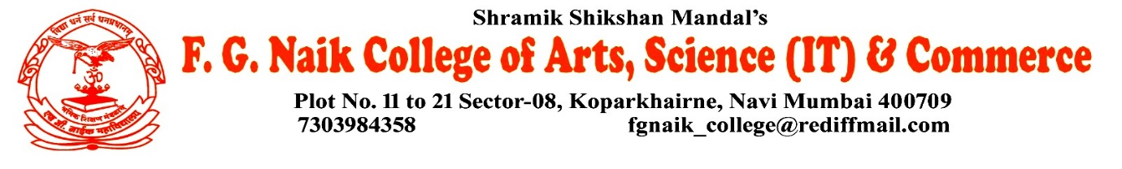

NSS UNIT
PARTICIPATION IN VIKSIT BHARAT YOUNG LEADERS DIALOGUE ONLINE QUIZ COMPETITION
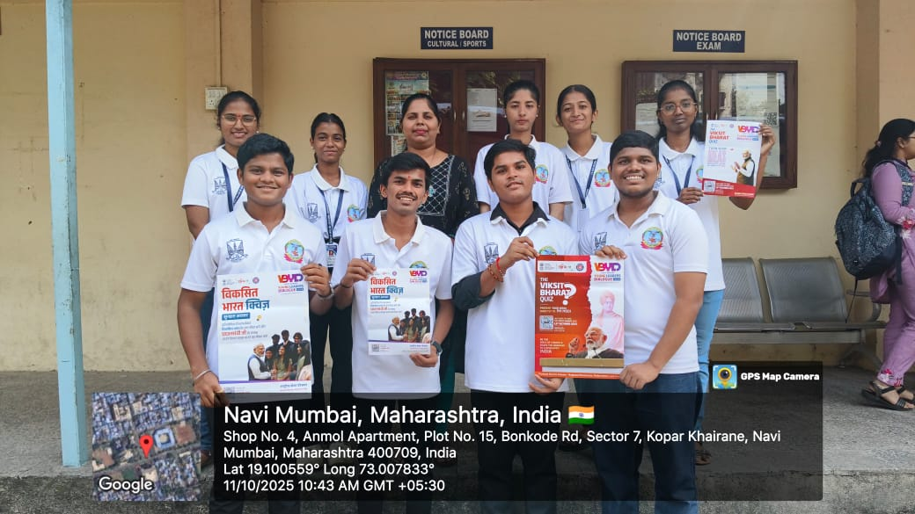

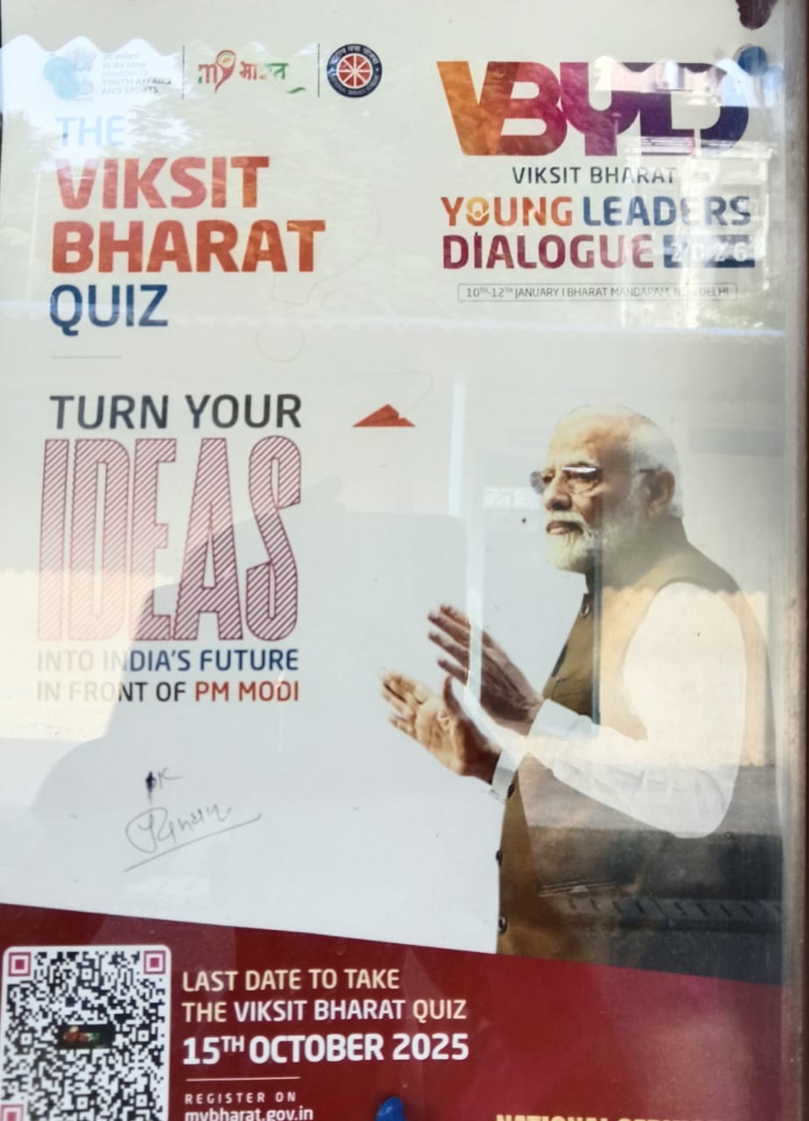

OBJECTIVE OF PROGRAM: To encourage youth participation in nation-building initiatives and enhance awareness about the vision of Viksit Bharat by engaging students in an informative and competitive online platform.
DATE: 11/10/2025
LOCATION: F.G Naik College
PARTICIPATING STAFF: All the NSS volunteers, teaching and the non-teaching staff of the college.
NUMBER OF VOLUNTEERS PARTICIPATING: 24
The NSS Unit encouraged and facilitated student participation in the Viksit Bharat Young Leaders Dialogue Online Quiz Competition organized by the Ministry of Youth Affairs and Sports. The quiz aimed to test and improve students’ knowledge about India’s development goals, leadership values, governance, and the role of youth in shaping the future of the nation.
The students actively participated in the online quiz with enthusiasm and sincerity. The competition helped in developing awareness, critical thinking, and a sense of responsibility among the participants towards the vision of a developed and self-reliant India.
PROGRAM DETAILS: The program commenced with a brief orientation, guiding students about the objectives and procedure of the online quiz competition.
The NSS Unit successfully coordinated student participation in the Viksit Bharat Young Leaders Dialogue Online Quiz Competition, motivating students to actively contribute towards national development through informed leadership and civic responsibility.

NSS IQAC
PROGRAM OFFICER CO-ORRDINATOR I/C PRINCIPAL

